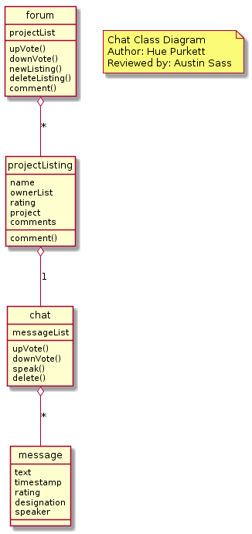

@startuml

hide circle

note "Chat Class Diagram\nAuthor: Hue Purkett\nReviewed by: Austin Sass" as Nhue

class chat{

messageList

upVote()

downVote()

speak()

delete()

}

class message{

text

timestamp

rating

designation

speaker

}

class forum{

projectList

upVote()

downVote()

newListing()

deleteListing()

comment()

}

class projectListing{

name

ownerList

rating

project

comments

comment()

}

message -d-o chat : \*

chat -d-o projectListing : 1

projectListing -d-o forum : \*

@enduml